Source: http://www.epa.gov/Region10/offices/oea/epaqag9d.pdf
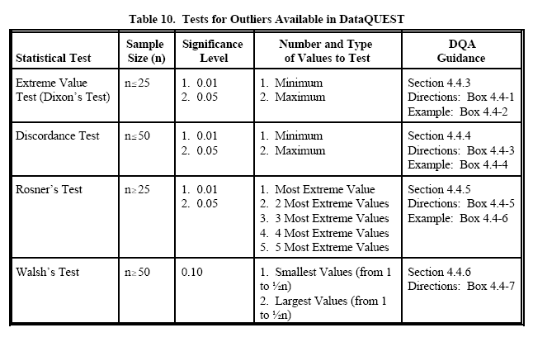
Source: http://pareonline.net/getvn.asp?v=9&n=6
Identification of Outliers
There is as much controversy over what constitutes an outlier as whether to remove them or not. Simple rules of thumb (e.g., data points three or more standard deviations from the mean) are good starting points. Some researchers prefer visual inspection of the data. Others (e.g., Lornez, 1987) argue that outlier detection is merely a special case of the examination of data for influential data points.
Simple rules such as z = 3 are simple and relatively effective, although Miller (1991) and Van Selst and Jolicoeur (1994) demonstrated that this procedure (nonrecursive elimination of extreme scores) can produce problems with certain distributions (e.g., highly skewed distributions characteristic of response latency variables) particularly when the sample is relatively small. To help researchers deal with this issue, Van Selst and Jolicoeur (1994) present a table of suggested cutoff scores for researchers to use with varying sample sizes that will minimize these issues with extremely non-normal distributions. We tend to use a z = 3 guideline as an initial screening tool, and depending on the results of that screening, examine the data more closely and modify the outlier detection strategy accordingly.
Bivariate and multivariate outliers are typically measured using either an index of influence or leverage, or distance. Popular indices include Mahalanobis’ distance and Cook’s D are both frequently used to calculate the leverage that specific cases may exert on the predicted value of the regression line (Newton & Rudestam, 1999). Standardized or studentized residuals in regression can also be useful, and often the z=3 rule works well for residuals as well.
For ANOVA-type paradigms, most modern statistical software will produce a range of statistics, including standardized residuals. In ANOVA the biggest issue after screening for univariate outliers is the issue of within-cell outliers, or the distance of an individual from the subgroup. Standardized residuals represent the distance from the sub-group, and thus are effective in assisting analysts in examining data for multivariate outliers. Tabachnick and Fidell (2000) discuss data cleaning in the context of other analyses.
How to deal with outliers
There is a great deal of debate as to what to do with identified outliers. A thorough review of the various arguments is not possible here. We argue that what to do depends in large part on why an outlier is in the data in the first place. Where outliers are illegitimately included in the data, it is only common sense that those data points should be removed. (see also Barnett & Lewis, 1994). Few should disagree with that statement.
When the outlier is either a legitimate part of the data or the cause is unclear, the issue becomes murkier. Judd and McClelland (1989) make several strong points for removal even in these cases in order to get the most honest estimate of population parameters possible (see also Barnett & Lewis, 1994). However, not all researchers feel that way (see Orr, Sackett, & DuBois, 1991). This is a case where researchers must use their training, intuition, reasoned argument, and thoughtful consideration in making decisions.
Keeping legitimate outliers and still not violating your assumptions. One means of accommodating outliers is the use of transformations (for a more thorough discussion of best practices in using data transformations, see Osborne, 2002). By using transformations, extreme scores can be kept in the data set, and the relative ranking of scores remains, yet the skew and error variance present in the variable(s) can be reduced (Hamilton, 1992).
However, transformations may not be appropriate for the model being tested, or may affect its interpretation in undesirable ways. Taking the log of a variable makes a distribution less skewed, but it also alters the relationship between the original variables in the model. For example, if the raw scores originally related to a meaningful scale, the transformed scores can be difficult to interpret (Newton & Rudestam, 1999; Osborne 2002). Also problematic is the fact that many commonly used transformations require non-negative data, which limits their applications. For this reason, many researchers turn to other methods to accommodate outlying values.
One alternative to transformation is truncation, wherein extreme scores are recoded to the highest (or lowest) reasonable score. For example, a researcher might decide that in reality, it is impossible for a teenager to have more than 15 close friends. Thus, all teens reporting more than this value (even 100) would be re-coded to 15. Through truncation the relative ordering of the data is maintained, and the highest or lowest scores remain the highest or lowest scores, yet the distributional problems are reduced.
Robust methods. Instead of transformations or truncation, researchers sometimes use various “robust” procedures to protect their data from being distorted by the presence of outliers. These techniques “accommodate the outliers at no serious inconvenience—or are robust against the presence of outliers” (Barnett & Lewis, 1994, p. 35). Certain parameter estimates, especially the mean and Least Squares estimations, are particularly vulnerable to outliers, or have “low breakdown” values. For this reason, researchers turn to robust or “high breakdown” methods to provide alternative estimates for these important aspects of the data.
A common robust estimation method for univariate distributions involves the use of a trimmed mean, which is calculated by temporarily eliminating extreme observations at both ends of the sample (Anscombe, 1960). Alternatively, researchers may choose to compute a Windsorized mean, for which the highest and lowest observations are temporarily censored, and replaced with adjacent values from the remaining data (Barnett & Lewis, 1994).
Assuming that the distribution of prediction errors is close to normal, several common robust regression techniques can help reduce the influence of outlying data points. The least trimmed squares (LTS) and the least median of squares (LMS) estimators are conceptually similar to the trimmed mean, helping to minimize the scatter of the prediction errors by eliminating a specific percentage of the largest positive and negative outliers (Rousseeuw & Leroy, 1987), while Windsorized regression smoothes the Y-data by replacing extreme residuals with the next closest value in the dataset (Lane, 2002).
Many options exist for analysis of non-ideal variables. In addition to the above-mentioned options, analysts can choose from non-parametric analyses, as these types of analyses have few if any distributional assumptions, although research by Zimmerman and others (e..g, Zimmerman, 1995) do point out that even non-parametric analyses suffer from outlier cases.

Source: http://www.cee.vt.edu/ewr/environmental/teach/smprimer/outlier/outlier.html#detect

Detecting outliers
There are numerous tests for identifying outliers. Four common outlier tests for normal distributions are the Rosner test, Dixon test, Grubbs test, and the box plot rule. These techniques are based on hypothesis testing rather the regression methods.

Rosner's Test
Rosner’s Test for detecting up to k outliers can be used when the number of data points is 25 or more. This test identifies outliers that are both high and low, it is therefore always two-tailed (Gibbons, 1994). The data are ranked in ascending order and the mean and standard deviation are determined. The procedure entails removing from the data set the observation, x, that is farthest from the mean. Then a test statistic, R, is calculated:
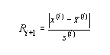
The R statistic is then compared with a critical value (Gilbert, 1987). The null hypothesis, stating that the data fits a normal distribution, is then tested. If R is less than the critical value, the null hypothesis cannot be rejected, and therefore there are no outliers. If R is greater than the critical value, the null hypothesis is rejected and the presence of k outliers is accepted. This test can also be used with log-normally distributed data, when the logarithms of the data are used for computation.
Dixon's Test
Dixon’s test is generally used for detecting a small number of outliers (Gibbons, 1994). This test can be used when the sample size is between 3 and 25 observations. The data is ranked in ascending order, then based on the sample size, the tau statistic for the highest value or lowest value is computed.
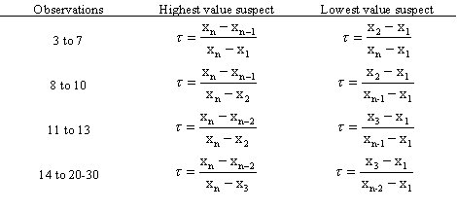
The tau statistic is compared to a critical value at a chosen value of alpha (Gibbons, 1994). If the tau statistic is less than the critical value, the null hypothesis is not rejected, and the conclusion is that no outliers are present. If the tau statistic is greater than the critical value, the null hypothesis is rejected, and the conclusion is the most extreme value is an outlier. To check for other outliers, the Dixon test can be repeated, however, the power of this test decreases as the number of repetitions increases.
Boxplot Rule
The boxplot rule is a visual test to inspect for outliers, see Figure 5 for example of a boxplot. The interquartile range is included into a box and the 5% and 95% confidence intervals are indicated with error bars outside of the box. Values that lie outside of the confidence interval are possible outliers (Iglewicz, 1993).
95% confidence interval limit: 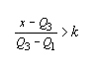and 5% confidence interval limit: 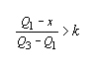
Grubbs' Test
Grubbs’ test is recommended by the EPA as a statistical test for outliers (US EPA, 1992). The EPA suggests taking the logarithms of environmental data, which are often log-normally distributed. The data are ranked in ascending order and the mean and standard deviation are calculated. The lowest or highest data point can be tested as an outlier.
The tau statistic for the smallest value is: 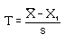. The tau statistic for the largest value is: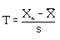
The tau statistic is compared with a critical tau value for the sample size and selected alpha (Taylor, 1987). If the tau statistic is greater than the tau critical, the null hypothesis is rejected and the conclusion is that the datum under consideration is an outlier. Figure 6 shows an example of a Grubbs' test

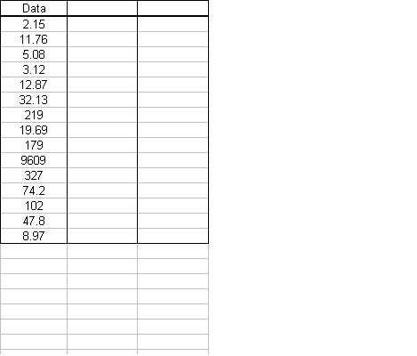

Figure 6. Grubbs' test calculation.

Conclusions
All of the above discussed statistical tests are used to determine if experimental observations are statistical outliers in normally distributed data sets. If an observation is statistically determined to be an outlier, the EPA suggests determining an explanation for this outlier before its exclusion from further analysis (US EPA, 1992). If an explanation cannot be found, then the observation should be treated as an extreme but valid measurement and it should be in further analysis (US EPA, 1992).
The tests for normal data set are easy to use and powerful, however, the tests for non-normal data more difficult and not as powerful (Iglewicz, 1993). Some of these tests are included in Barnett and Lewis (1984). In many situations the data can be transformed to approximate a normal distribution and it can be analyzed using the techniques presented above (Iglewicz, 1993).

Variables
- alpha = the probability of false positive conclusion for a statistical test
- i = rank of the observation
- k = critical value in the boxplot rule
- MAD = median of the absolute deviation about the median
- n = number of observations in a data set
- R_{i+1} = Rosner's test statistic for determining if i+1 most extreme values are outliers
- s = standard deviation
- s^{(i)} = standard deviation of n-i data points after the i most extreme have been deleted
- S_{bi} = bi-weight estimator of location
- tau = the test statistic ratio for Dixon's test
- u_{i} = quotient of the deviation about the mean and MAD
- x = the farthest data point from the mean in Rosner's test or a data point outside the upper or lower cutoff in the boxplot rule
- x_{i} = ith observation in the data set when data ranked in ascending order
- x^{(i)} = the most outlying data point after the i most exterme have been deleted
- xbar^{(i)} = the mean of n-i data points after i most estreme have been deleted
- x_{m}, x = median
- x_{n} = the highest data point when data ranked in ascending order
- x_{n-1} = the second highest data point when data ranked in ascending order
- z_{i} = z-score of the ith observation

Dixon’s Test
- Detection of a single outlier
- Assumes Gaussian distribution
- http://www.chem.uoa.gr/applets/AppletQtest/Text_Qtest2.htm

Walsh's Outlier Test
http://www.statistics4u.com/fundstat_eng/ee_walsh_outliertest.html
J.E. Walsh developed a non-parametric test to detect multiple outliers in a data set. Although this test requires a large sample size (n>220 for a significance level α of 0.05), it may be used whenever the data are not normally distributed. Following are the instructions to perform a Walsh test for large sample sizes:
Let X₁, X₂, ... , X_{n} represent the data ordered from smallest to largest. If n<60, do not apply this test. If 60<n<=220, then α = 0.10. If n >220 then α = 0.05.
Step 1: | Identify the number of possible outliers, r >= 1.
Step 2: | Compute  c = ceil(), k = r + c, b² = 1/α, and  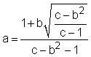  where ceil() indicates rounding the value to the largest possible integer (i.e., 3.21 becomes 4).
Step 3: | The r smallest points are outliers (with a α% level of significance) if X_{r} - (1+a)X_{r+1} + aX_{k} < 0
Step 4: | The r largest points are outliers (with a α% level of significance) if X_{n+1-r} - (1+a)X_{n-r} + aX_{n+1-k} > 0
Step 5: | If both of the inequalities are true, then both small and large outliers are indicated.

Walsh pro: does not assume a given distribution.

